Note to Teacher:

The following lesson plans are a part of the Project SCOPE (Security Clearance Overview and Preparation Education) curriculum. They are recommended for 7th grade students, but may also be appropriate for older students, depending on where and how they are incorporated into your curriculum. To assist you in preparing a pedagogically appropriate lesson for your students, sample questions, worksheets, activities and discussion points have been provided for each lesson.

The lessons provided contain possible connections to these subjects, though the list below is not exhaustive:
- Advisory sessions
- Career studies
- Government class
- Language arts class
- History class
- Curriculum related to:
  - Themes of rites of passage or codes of honor
  - Different ways to express opinions, op-eds
  - Value systems in different cultures

First Lesson Plan: Introduction to the Intelligence Community

The first lesson plan is intended to introduce students to the intelligence community through an analysis of political cartoons and videos presenting factual information. The second plan in this sequence provides students a connection between what they learned about the intelligence community in the first lesson and codes of honor and good decision making.

Objective:

- Students will decipher political cartoons to determine their intended message.
- Students will identify the range of opinions the U.S. public has about the intelligence community.
- Students will name at least one mission of the intelligence community.
- Students will identify at least one fact and one false impression the public has about the intelligence community.

Opening

The opening for this lesson will vary depending on the curriculum for your course. The goal of the opening is to help students understand how this lesson will relate to the larger themes of your course or tie into something they have recently studied.

Focus Activity

Students will start by completing the first two columns of a Know-Want to Know-Learn (KWL) chart (see Appendix B) individually. Students should then split into groups of 4-5 (or a size of your choice) to share with one another what they have on their charts. Once students have shared in groups, you can put the “Know” and “Want to Know” columns on the board and ask each group to share items from those columns until what you have on the board reflects everything from students’ charts. (Consider going group by group and asking each group to share something they do not already see on the board. Once every group has shared, ask if there are any groups who have additional items that have not yet been put on the board.)

This is an opportunity for students to explain the things they already know and be leaders/experts in the room. When a group shares something they “know,” encourage them to explain it and let other groups ask questions.

If a student shares something that is inaccurate, ask a question to see if they can correct the misunderstanding. If part of what they have said is correct, praise their accuracy for that portion while also pointing out that they are not fully correct about the other parts. If a student shares an opinion rather than a fact, note that they have shared an opinion and that you will be discussing different opinions on this subject later in class. Only put accurate factual items on the board.

Political Cartoon Activity

Appendix C includes 9 political cartoons about the U.S. intelligence community, with cartoons that appear to be both in support and against what the community does. Choose a selection of these cartoons (with opinions on both sides) for the following activity.

To introduce the activity, you might say to students:
Many folks in the U.S. have opinions about the intelligence community. Today, we are going to examine some of those opinions in the form of political cartoons.

For the activity, break students into groups or pairs. A sample worksheet with questions for students is included in Appendix D. You can use this worksheet as is, modify it for your own classroom needs or write your own questions for the cartoons. You may also choose to model answering the questions for the first cartoon with the class or provide a rubric to help students understand your expectations for the depth and length of their answers. As students work, move through the room to ask and answer questions of student groups.

Debrief each cartoon with the whole class. Some sample responses to look for on the provided worksheet are offered in Appendix E.

Video Activities

After the discussion about the political cartoons, ask the class:

We now know some of the opinions people in the U.S. have about the intelligence community. But what, exactly, is the intelligence community and what do people who work in it do?

If applicable, point out information from the KWL chart that may help answer this question. Next, screen the two videos below and ask students to complete the chart in Appendix F as they watch. Depending on the technology set-up of your classroom, you may provide students time to self-screen the first video on individual devices, as this will allow them to pause, rewind, etc. to capture pertinent information for the video worksheet.

Video 1: The Intelligence Community Explained

For the second video, you can watch as a whole class, pausing before each fact/fiction answer is revealed. Have students raise hands for whether they think the information is fact or fiction and then have 1-2 students explain their response. Then, press play and listen to the answer and reasoning given in the video. Have students complete the chart on page 2 of the video worksheet as you go.

Video 2: Intelligence Community Fact vs. Fiction

Debrief the videos and worksheet with a class discussion. The answer key to the video worksheet (provided in Appendix G) includes responses that you should look for students to name in the discussion as you debrief.
Closing Activity

Have students complete their KWL charts by entering the information they learned as a result of today’s lesson. You may choose to collect the charts to assess whether or not students met the objectives for the lesson. If they did not meet the objectives, you may want to plan a review of key points during your next lesson.

Second Lesson Plan: Making Good Decisions

Objective:

- Students will identify the rigor (code of honor) used in the intelligence community to vet prospective employees.
- Students will identify the core values they hold that will help them in making difficult decisions throughout their lives.
- Students will understand how their behavior today may affect their future career options.

Opening

You may choose to have students answer this question in a think/pair/share, in small groups, or via written entrance tickets.

What is one thing you learned about the intelligence community in the last lesson?

Depending on the method you have chosen for students to answer this question, you may ask a few students to share verbally or you may read a few entrance ticket cards aloud. Next, you will want to tie today’s lesson into the prior lesson:

During our last lesson, we learned about the intelligence community and opinions Americans have about it. One of the things that we learned during the lesson is that a person working in the intelligence community must be trustworthy. Today we are going to learn more about the government vetting process throughout which an individual must demonstrate that they are trustworthy, reliable and a good decision maker. Since these characteristics are not just important to working in intelligence, but will also help you throughout your life as you navigate the challenges of growing up and becoming an adult, we are also going to talk more today about how to make good decisions. Together, we will develop a resource you can use whenever you are faced with a difficult decision.

Focus Activity:

For the focus activity, consider how you have structured the Opening and Reflection sections of the plan to provide balance and variety in the way students are grouped and how they are asked to respond. Consider having students respond to each question as a think/pair/share or in small groups before debriefing as a class. Ask the following questions, one at a time (the amount of time per question will vary depending on your grouping strategy):

- How many of you have ever made a mistake? What was that mistake and how did you handle it?
- What was the aftermath of your mistake? How did others react to your mistake and did they forgive you? Punish you?
- Have you ever done anything that you couldn’t “un-do?” How did you feel?
Security Clearances and Adjudication

Depending on your class and curriculum, you may choose to structure this activity in different ways. For a literature, history or writing class, consider having students complete a critical reading exercise using the handout provided in Appendix H, the National Adjudicative Guidelines or Wikipedia’s entry on security clearances (focusing on the US). Some questions you may want students to answer include:

- What characteristics does the U.S. government expect someone with access to national secrets to possess?
- Name some of the characteristics upon which the government cannot base a security clearance decision.
- What are some of the factors or personal situations the government may investigate when determining whether someone should be granted a security clearance?

Video Activity:

Values and Decision Making: How to Avoid Regret: This short video (approx. 7 minutes) from the social movement and nonprofit Because I Said I Would discusses research on regret and decision making, asking students to identify their own “core values” or “code of honor” to use in making difficult decisions.

Instructions for Students:
We just looked at what the U.S. government expects of individuals working on the nation’s secrets. Now, we are going to spend some time developing our own codes of honor – in other words, what are the characteristics that you value most? To help us do this, we are first going to watch a short video. While you watch, write down three “hot spots” (meaning anything that you didn’t understand, or something you thought was interesting, or something you had a strong opinion about). We will share these after the video.

After video, have students share “hot spots” either as a whole group or in small 4-5 person groups before bringing it back as a whole group to share. You decide based on the size of the group and on how much time you have available.

Below are potential “hot spots” that students may raise, or that you may choose to raise should they not come up naturally in discussion:
- In 2005, researchers from University of Illinois asked 121 participants what moment they would go back to if they could change a decision they had made or action they had taken
- You would think that the greatest regret would be over decisions or outcomes that cannot possibly be changed; where there is no way to make it better now
- Survey studies show that people don’t regret things they can’t change; instead, they regret things they still have the power to change
- Top five regrets were based on decisions related to:
  - Self-improvement
  - Parenting
  - Relationships
  - Career decisions
  - Biggest regret, consistent since 1949: Education
- Video posits that some of what defines regret is the opportunity for a decision itself
- Code of honor: a list of guiding principles to help in making decisions
- Code of honor must be:
  - Memorable
  - Concise
  - Practical
- Right decision requires contemplation: should I fight for this? Should I commit to it? Should I be honest?
- Personal code of honor is parallel to society having a set of standards/laws – it guides you in making consistent choices
- People may make decisions based on belief systems, political affiliation, personal experiences, but we still have to prioritize what means the most to us within that mix
- How to write a code of honor:
  - Write down a list of your values
  - No more than 5
  - Make an acronym
  - Commit it to memory
- A code of honor isn’t practical if you can’t remember it
- Having a code of honor helps you to avoid making decisions based on impulse, fads, or the heat of the moment

Here are some questions that the video raises that you may also choose to discuss:
- What can we do to eliminate regret?
- How committed are you to good citizenship? What does good citizenship mean?

Writing Activity

Have students complete the worksheet in Appendix I. You may choose to allow time for students to complete this independently, or you may guide students through it with prompts for each section. By the end, students should have a concise and memorable set of values that represent their individual code of honor.

To tie this into your curriculum and standards, consider having students write to a prompt regarding their code of honor. The prompt may relate to the study of specific themes in history, ELA or another course, or the prompt may be more open ended, requiring students to instead demonstrate mastery writing in a specific structure (argument essay, op-ed, etc.) or voice (formal, informal, persuasive, etc.).

Reflection

Reflection can be written or verbal, depending on your curriculum and objectives for this lesson. As an example, in the ELA classroom, this reflection might be written as students’ exit tickets for the day, or it might be used as an introductory activity during the following class session in preparation for a related essay prompt.

Alternately, this reflection could be completed verbally, with a think/pair/share, or by having students raise hands to indicate “yes” for the first question, with a short discussion of the second.

Reflection Questions:
- Did you know that decisions you make now can affect the rest of your life, including your job and future?
- How can you use your code of honor to guide you when faced with a difficult decision?

Appendix A: Additional Resources

Here are some links to other videos we thought were great, but didn’t incorporate into these lessons:

- Decision Making
  - Making Tough Choices with Kid President
- Intelligence Community:
  - What Does the Intelligence Community Do?
  - 4 Unexpected Security Clearance Jobs
  - What does a security clearance holder do?
  - What’s a security clearance worth?

Here are additional resources to help students analyze political cartoons:
- Analyzing Political Cartoons
- Library of Congress: Teaching with Primary Sources

Appendix B: KWL Chart

The Intelligence Community and Government Surveillance
What do you already know about this topic? | What do you want to know about this topic? | What have you learned about this topic?

Appendix C: Political Cartoons

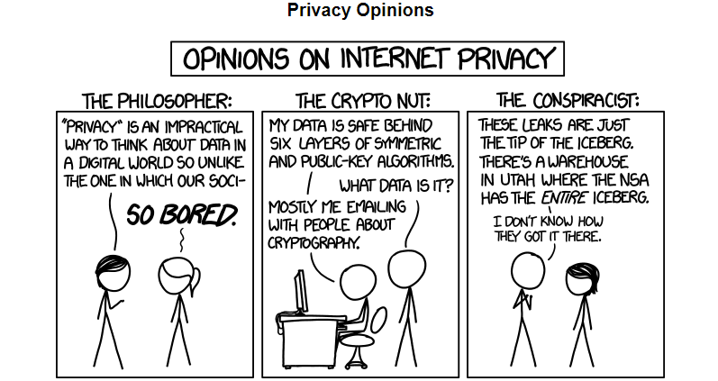

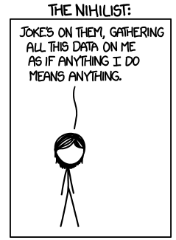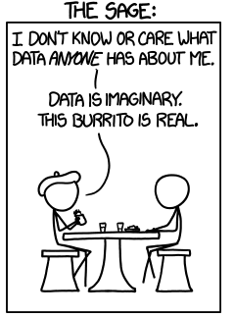

I’m the philosopher until someone hands me a burrito.

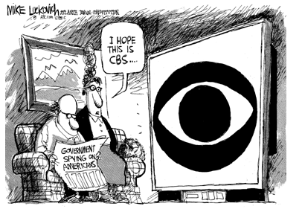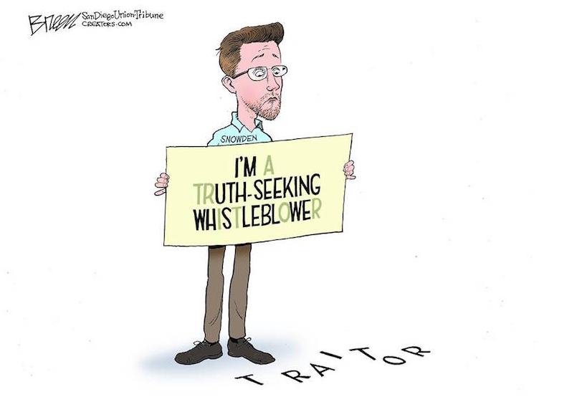

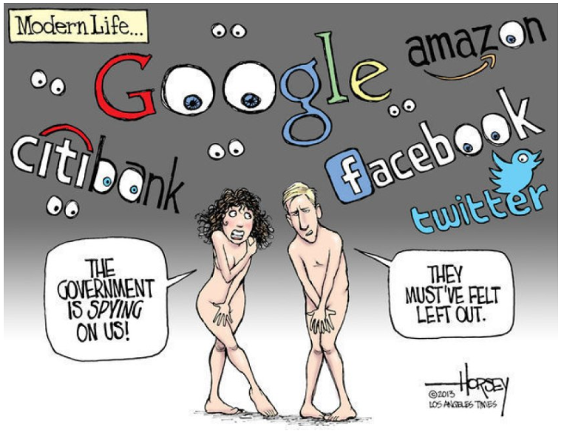

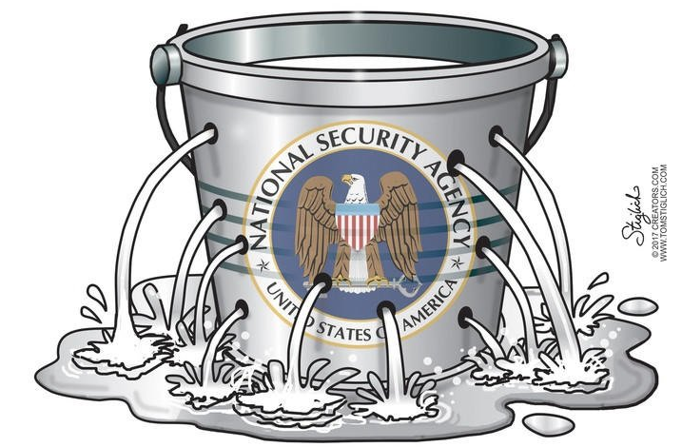
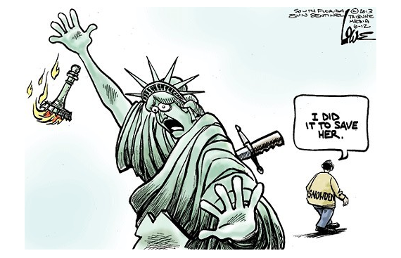

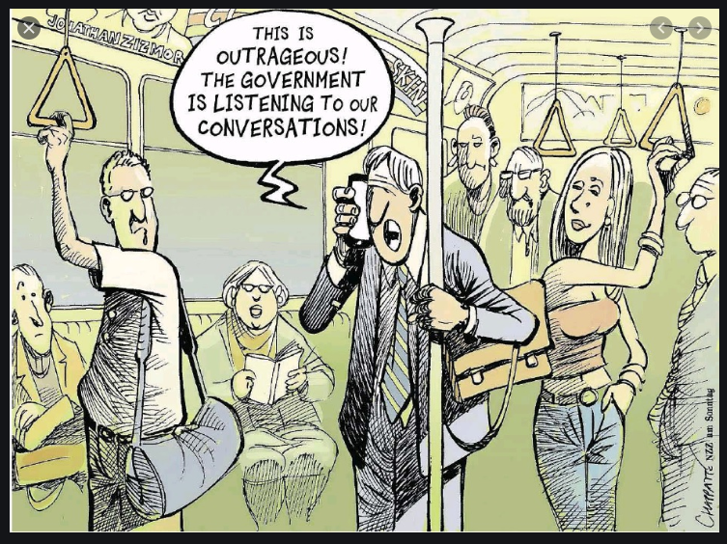
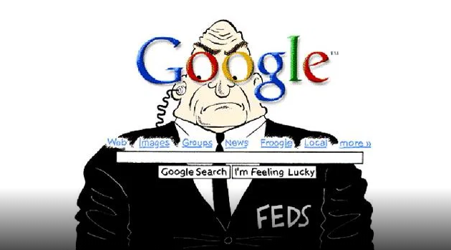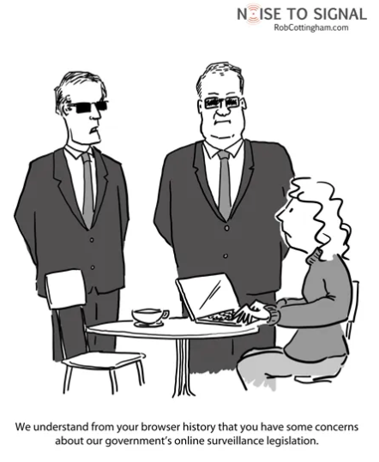
Appendix D: Sample Political Cartoon Worksheet

Name: ______________________ Date: _________________

For this exercise, you will work with your group or partner to decipher the following political cartoons:

Cartoon 1: Cartoon 2:

Cartoon 3:

I’M THE PHILOSOPHER UNTIL SOMEONE HANDS ME A BURRITO.

Answer the following questions for each cartoon.

 | Cartoon 1 | Cartoon 2 | Cartoon 3
Who do you think is depicted in the cartoon? Is there anyone specific named? If so, who is that person and what do you know about them?

(If no one in your group knows who the named person is, you may use a search engine to look them up.)
What does this cartoon suggest the intelligence community does?
What opinion do you think the illustrator of this cartoon has about the intelligence community and surveillance? Cite at least two pieces of evidence from the cartoon to support this.
Do you think the cartoonist was effective in conveying their message? Why or why not?

Appendix E: Sample Responses for Appendix D Worksheet
 | Cartoon 1 | Cartoon 2 | Cartoon 3
Who do you think is depicted in the cartoon? Is there anyone specific named? If so, who is that person and what do you know about them?  (If no one in your group knows who the named person is, you may use a search engine to look them up.) | Two men in suits and a woman in what looks to be a coffee shop. The men in suits appear to be government agents, both because of what they say and because of how they are dressed. It looks like the woman is just a regular citizen. | There is a single man in this cartoon and his shirt says “Snowden.” This suggests that he is Edward Snowden, who leaked information about government intelligence and surveillance programs to journalists in 2013. | There doesn’t seem to be specific people named in this cartoon, but each panel is dedicated to a different type of person: the philosopher, the crypto-nut, the conspiracist, the nihilist and the sage. There is a description for what each type of person may believe.
What does this cartoon suggest the intelligence community does? | This one suggests that the community is spying on the average citizen. | This cartoon is calling Snowden a traitor. That suggests the intelligence community is doing something critical to the nation and that Snowden betrayed the US. | The approach of the different characters suggests that the intelligence community is collecting data on citizens.
What opinion do you think the illustrator of this cartoon has about the intelligence community and surveillance? Cite at least one piece of evidence from the cartoon to support this. | Opinion:  - The intelligence community is overstepping its bounds.  Sample Evidence:  - The men seem to be interrupting the woman at a coffee shop where she is going about her regular business.  - The men know about the woman’s browser history.  - The men are suggesting the woman holds an unfavorable opinion about legislation directly related to government surveillance; they seem to want to discuss this with her as if she has done something wrong. | Opinion:  - The intelligence community does essential work that Snowden has undermined.  Sample Evidence:  - Snowden is holding a sign that paints him as a hero, but the word “traitor” clearly appears on the ground beneath the sign.  The following sample evidence is not in the cartoon, but may be something students know through prior knowledge or a search to read about who Snowden is:  - Snowden claimed that he leaked information because he wanted the US public to know about covert government surveillance; government officials said that he compromised national security and put Americans at risk. It seems the cartoonist is suggesting that the government officials are right by using the word “traitor.” | Opinion:  - The intelligence community may or may not spy on citizens, but it ultimately doesn’t matter.  Sample Evidence:  - Philosopher, Conspiracist, Crypto-nut and Nihilist all seem to be negative portrayals, while the Sage is not only a positive descriptor (sage=smart, wise, etc.), but also the one that the author identifies with based on the text below the panels.  - The Conspiracist seems to be crazy, while the Crypto-nut seems to be consumed with hiding information that ultimately isn’t even important to hide. The Sage doesn’t care what info people gather and has more pressing concerns, like eating the burrito.
Do you think the cartoonist was effective in conveying their message? Why or why not? | Answers will vary student to student. | Answers will vary student to student. | Answers will vary student to student.

Appendix F: Video Worksheet

Name: _______________________ Date: ______________

Video 1: The Intelligence Community Explained
As you watch this video, you will see this chart. Fill in the boxes below with information from the video.
Office of the Director of National Intelligence:

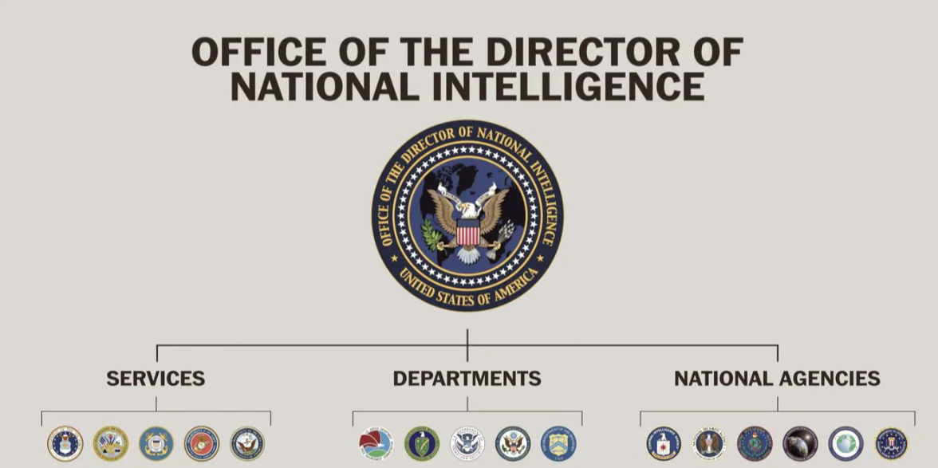
National Agencies:
Departments:

Armed Forces/Services (Air Force, Army, Coast Guard, Marine Corps, Navy):

U.S. Justice Department, Office of National Security and Intelligence:

Department of Energy, Office of Intelligence and Counterintelligence:

Department of Homeland Security, Office of Intelligence and Analysis:

Department of State, Bureau of Intelligence and Research:

Department of the Treasury, Office of Terrorism and Financial Intelligence:

National Security Agency:

Federal Bureau of Investigations Counter-intelligence Unit:

National Reconnaissance Office:

National Geospacial Intelligence Agency:

Defense Intelligence Agency:

Central Intelligence Agency:

Additional Notes from Video 1:

Video 2: Intelligence Community Fact vs. Fiction

 | Your initial guess and why you think this is fact or fiction. | Fact or Fiction? | Why?
#1: The CIA is the super agency in charge of all intelligence operations.
#2: You need to be trustworthy to work in the intelligence community.
#3: In order to work in the intelligence community, you have to speak many languages, know martial arts and be a weapons expert
#4: You can work in the intelligence community and have a regular personal life.

Appendix G: Video Worksheet (from Appendix F) with Answers

Name: _______________________ Date: ______________

Video 1: The Intelligence Community Explained

As you watch this video, you will see this chart. Fill in the boxes below with information from the video.
- Set up in 2004
- Oversees all the other agencies/departments

National Agencies:
- Help advise the Director of National Intelligence
Departments:
- Offices embedded in other government agencies to help with their missions
Armed Forces/Services (Air Force, Army, Coast Guard, Marine Corps, Navy):
- Each division has its own intelligence organization to serve its needs
U.S. Justice Department, Office of National Security and Intelligence:
- Drug cartels
- Counter-narcotics efforts
Department of Energy, Office of Intelligence and Counterintelligence:
- Intelligence on foreign nuclear weapons
- Global energy issues
Department of Homeland Security, Office of Intelligence and Analysis:
- Domestic threats
Department of State, Bureau of Intelligence and Research:
- Helps secretary of state and ambassadors
Department of the Treasury, Office of Terrorism and Financial Intelligence:
- International economic threats
National Security Agency:
- Monitors foreign information systems
- Collects cell phone and email data
- Sometimes pulls info about Americans
Federal Bureau of Investigations Counter-intelligence Unit:
- Helps protect American homeland from spies in the U.S.
National Reconnaissance Office:
- Designs, builds, launches spy satellites
National Geospacial Intelligence Agency:
- Charts & maps Earth
- Maps human activity for national security
Defense Intelligence Agency:
- Foreign military intelligence

Central Intelligence Agency:
- Collects & analyzes foreign intelligence
- Helps inform policy makers

Additional Notes from Video 1:
- Funding is split into two big buckets: National Intelligence Program and Military Intelligence Program
- Beyond this, information about how the money is doled out is classified
- In 2015, 60.9 billion dollars went to the intelligence part of the budget

Video 2: Intelligence Community Fact vs. Fiction

 | Your initial guess and why you think this is fact or fiction. | Fact or Fiction? | Why?
#1: The CIA is the super agency in charge of all intelligence operations. | Answers here will vary student to student. | Fiction | The CIA is one of 17 agencies, all overseen by the Office of the Director of National Intelligence
#2: You need to be trustworthy to work in the intelligence community. | Answers here will vary student to student. | Fact | People who work in national intelligence have to go through a vetting process; people who have a recent criminal record, lots of debt, or substance issues usually don’t pass
#3: In order to work in the intelligence community, you have to speak many languages, know martial arts and be a weapons expert | Answers here will vary student to student. | Fiction | Teachers, lawyers, accountants, plumbers, etc. work in the intelligence community. The skills named might help you get a different type of job, but not having them doesn’t keep you out of the industry.
#4: You can work in the intelligence community and have a regular personal life. | Answers here will vary student to student. | Fact | Most intelligence community workers have regular 9-5 jobs.

Appendix H: Security Clearances and Adjudication Handout

The following is excerpted from the U.S. Department of State’s Security Clearances website:

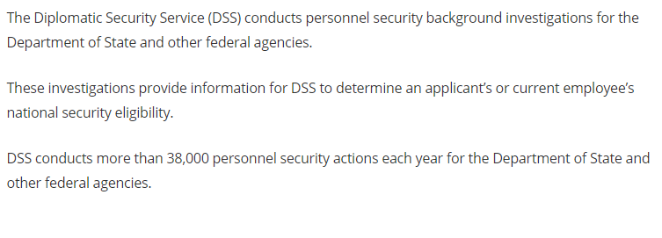
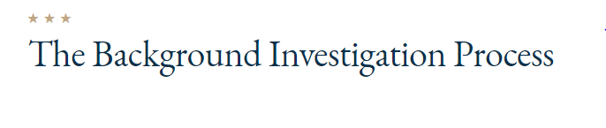
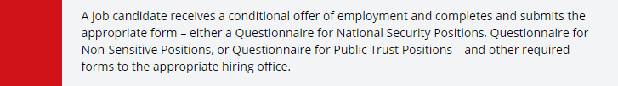

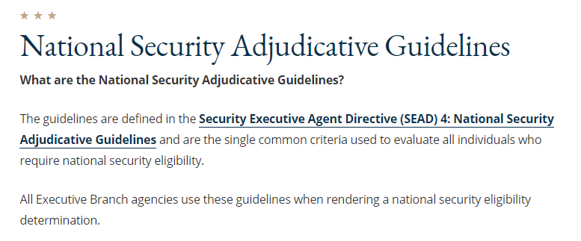
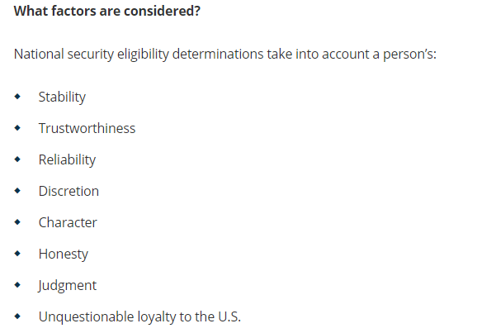

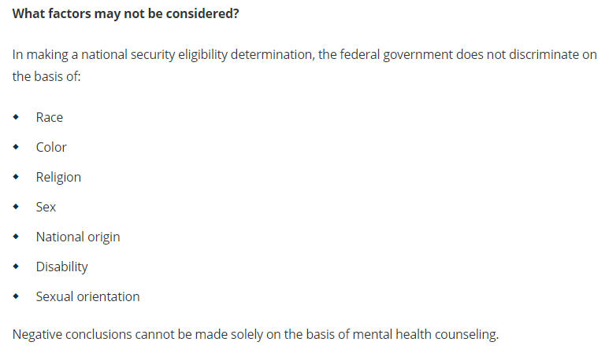

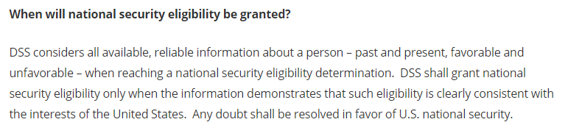
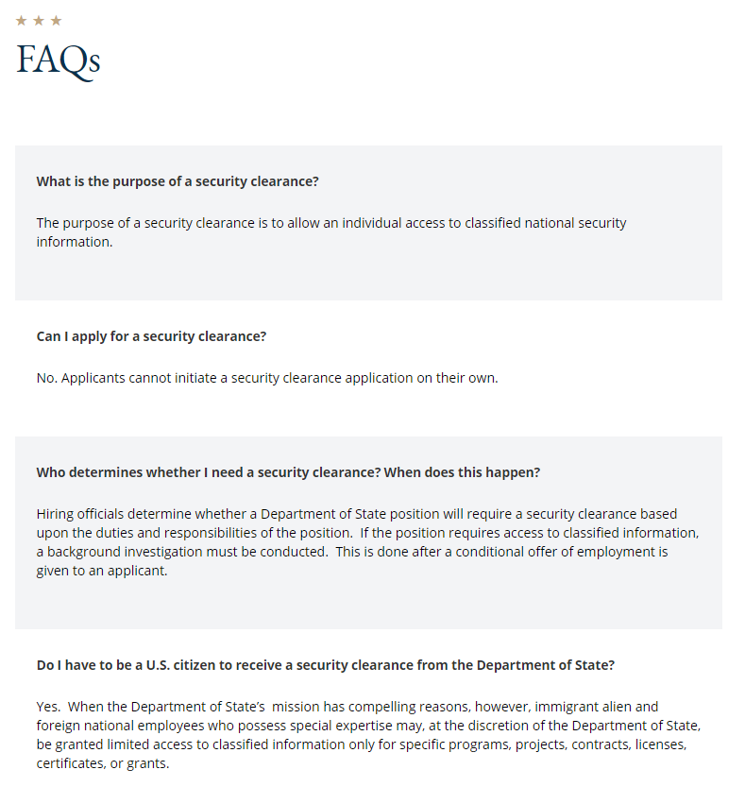
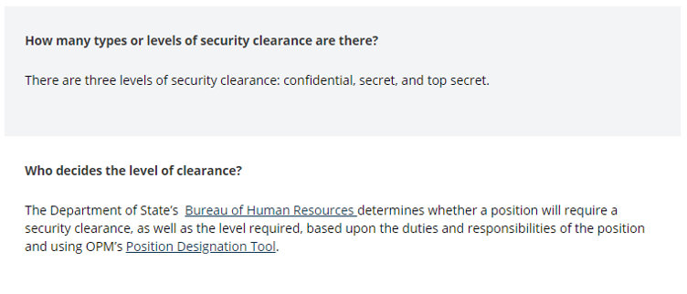
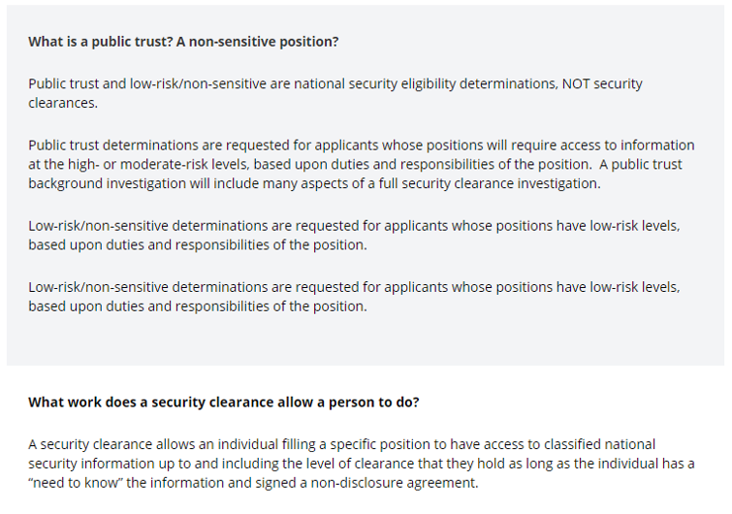
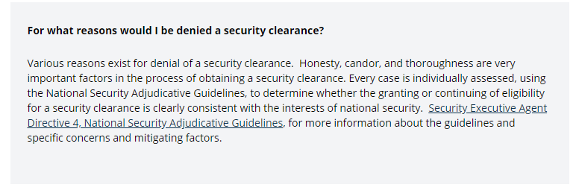

Appendix I: Determining Your Code of Honor

Name: ______________________ Date: ______________________

Step 1: Read through the words in the list below. Circle any words that resonate with you, that you think are important or that you want to be. Don’t overthink your selections and don’t limit yourself! If you think of a characteristic that is important to you that you don’t see on this list, write it down on this page.

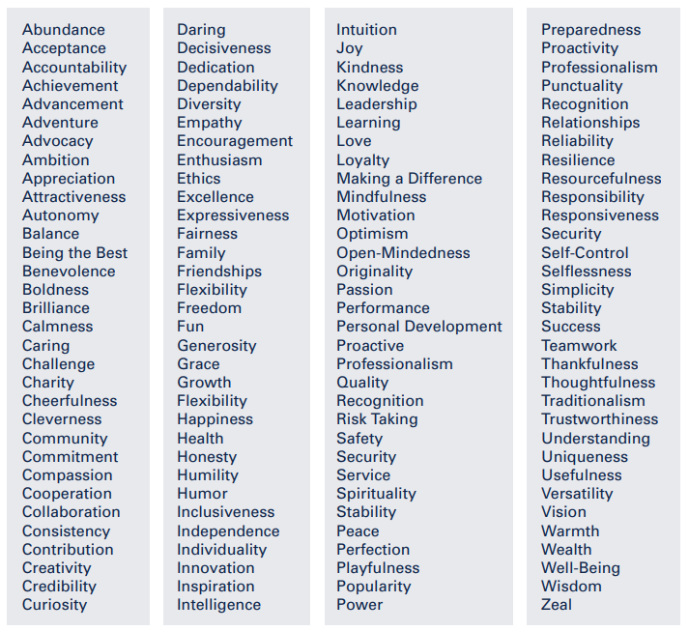

Step 2: Categorize the items you circled on the first page by grouping together words that are similar or describe the same thing. Try to group into no more than 5 categories.

Step 3: Choose one word from each group that best represents the label for the entire group. Don’t overthink your labels! There are no right or wrong answers – this is about the words that represent your code of honor. You get define what you want those words to be and you need to feel comfortable and confident living by them.

Step 4: See if you can arrange your words to create an acronym, or in another way that helps to make them memorable to you. Commit your code of honor to memory.

